How to make a homemade compass
Equipment
Needle, magnet, greaseproof paper, water, bowl, red and blue felt tip, scissors
- Rub one end of the needle with a magnet. Do this for 30 seconds. Then use the red felt tip to colour the end. | 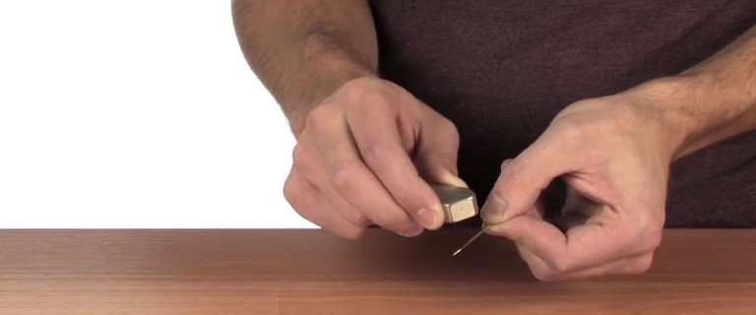
- Repeat with the other end of the needle. This time colour the end blue. The two ends represent the north and south poles that you would find on a bar magnet. | 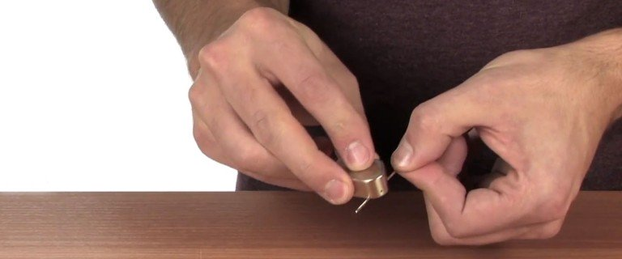
- Cut out a small circle from the greaseproof paper – the diameter needs to be about 2.5cm | 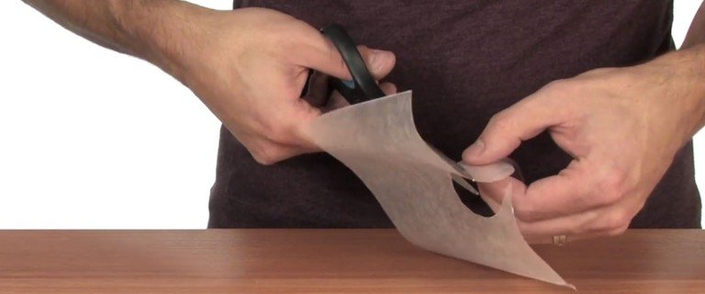
- Thread the needle through the paper, so that both ends of the needle are showing through the top. | 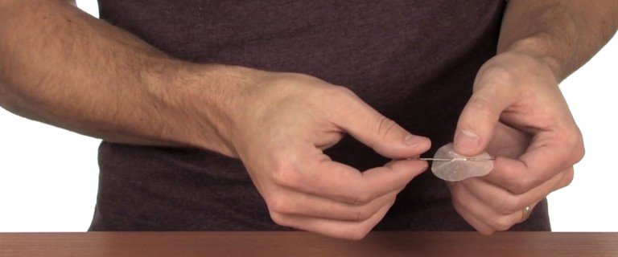
- Fill a bowl with water and carefully lay the needle and paper onto the surface, so that it floats. | 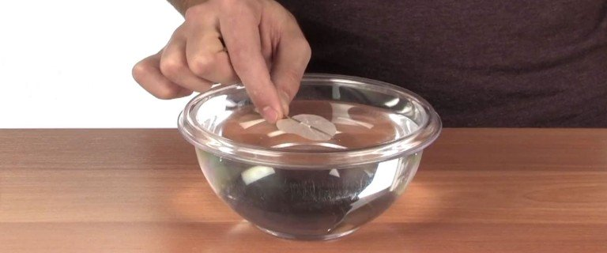
- Watch with amazement as your needle spins in the water to face north! If you have access to a real compass, or have an app on your phone, you can check to see how accurate your homemade version is. | 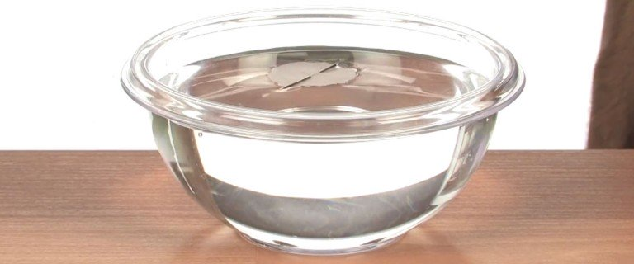

What is happening?
Rubbing the needle with the magnet leaves a slight residue behind. This causes the needle to become magnetised. The earth’s magnetic field creates an invisible force, which pulls on the needle, which makes it turn in the water, to face north.

*Key vocabulary is written in red.

