How to make a fireworks in a glass!

This is a very cool and simple experiment. Just don’t drink the water!
Equipment
Warm water
Oil
A tall glass
Food colouring
Method
- Fill a tall glass with warm water.
- Pour a small amount of oil into another container and add a few drops of food colouring.
- Give it a good stir, if it doesn’t mix, add a little bit of water.
- Pour the food colouring and oil mixture into the warm water and watch the fireworks!

What’s happening?
Oil and water don’t mix. Also oil is less dense that water (meaning there is less of it in the same volume) and therefore floats on top of the water in a nice layer. The food colouring we used was water-based and therefore does not mix with the oil, instead it sinks through the oil into the water. Since the addition of the colouring makes the food colouring heavier than the water, it sinks to the bottom leaving trails of colour – a bit like fireworks!

More about floating and sinking..

Which of these is the odd one out and why?
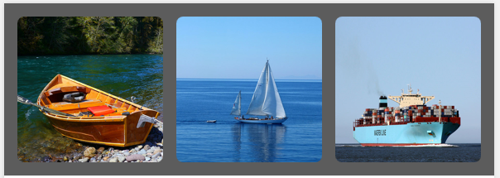

Try making a boat from Lego and seeing how many pennies it will hold.
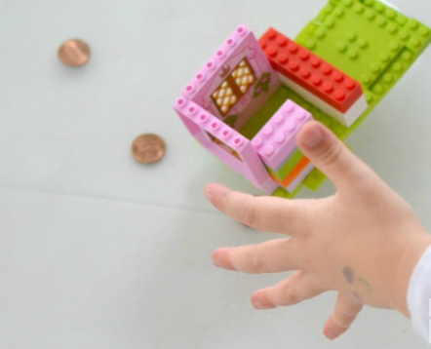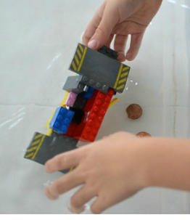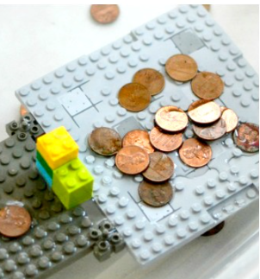

Watch these clips for more information
https://www.bbc.co.uk/iplayer/episode/b0bc29rr/kit-pup-series-1-7-floating-and-sinking
https://www.youtube.com/watch?v=nwbIraFDjjU

