
Oxford Diocesan Bucks Schools Trust (ODBST)
“ODBST - Empowering Lives, Flourishing Together”

Living ‘life in all its fullness’ (John 10:10)

Investment Policy

ODBST Level 1 Statutory Policy: | ALL Schools require this policy with no changes allowed to core text. No changes are necessary to personalise this with school name and branding, as this is a Trust level policy for use, without change, by all schools, except where a school contact is required as identified in the content of the policy. LGCs will note adoption in LGC meetings. Review will take place at Trust level, and schools will be notified of updates and review dates as necessary.
Other related ODBST policies and procedures: | ODBST Finance Manual
Committee responsible: | FRAPP
Approved by: | FRAPP
Date Approved: | 27th September 2023
Review date: | Autumn 2026

In reviewing this policy the Trust Board has had regards to the Equality Act 2010 and carried out an equality impact assessment. It is satisfied that no group with a protected characteristic will be unfairly disadvantaged.

Contents
Purpose and scope 3
Responsibility 3
Objectives 3
Counterparty risk 3
Counterparty Restrictions 3
Assessing liquidity needs 5
Investment Products 5
Investment Decisions 5
Monitoring & Reporting 5
Review 5
Authorisation of cash transfers 5

Purpose and scope
To set out the processes by which the Trust can invest funds surplus to day-to-day operational requirements and to ensure that investment risk is properly and prudently managed.
In doing so, Trustees must:
- Act within their Charity’s power to invest
- Set investment objectives
- Set the parameters that deposit counterparties need to meet
- Consider the level of liquid cash required to be held either overnight or within current accounts
- Approve the type of products that the Trust can invest in and seek external guidance if required
- Define processes to manage and make investment decisions
- Monitor and review investments on a regular basis

Responsibility
The Trustees delegate the day-to-day responsibility of managing and implementing the investment policy to the CEO and CFO to ensure investments are managed in accordance with this policy and monitor regularly how the Trust’s investments are performing.

Objectives
To identify a level of funds that can be placed on deposit to generate additional interest income for the Trust in order to support its on-going charitable objectives.
Any investment decisions must be supported by a cashflow forecast that reduces the risk of the Trust not having the liquidity required to carry out its day-to-day activities.

Counterparty risk
Following the Banking Crisis in 2007/2008, The Bank of England have (through the FSA and latterly, the FCA and PRA) implemented changes to stress testing and capital requirements of UK FCA registered banks to ensure the stability of the UK Banking system.
As such, the Trust can only make cash deposits with institutions with a UK banking licence and regulated by the FCA and PRA.

Counterparty Restrictions

For Institutions with a “good” or better credit rating or implied credit rating (also known as Investment grade), the Trust can deposit a maximum of £3,000,000 (plus interest accrued) in any one institution.
These ratings include:
Baa3 / P-3 or better (Moody’s) or
BBB- / A-3 or better (S&P) or
BBB- / F3 or better (Fitch) or
An implied rating of BBB- or better

The Credit rating or Implied Credit Rating will be checked at the time of placing a deposit with a new bank.
It is worth noting that Implied Credit Ratings are usually the ‘long term’ position, however, the Trust will only by depositing ‘short term’ in deposits with a maturity date or notice period of 12-months or less.

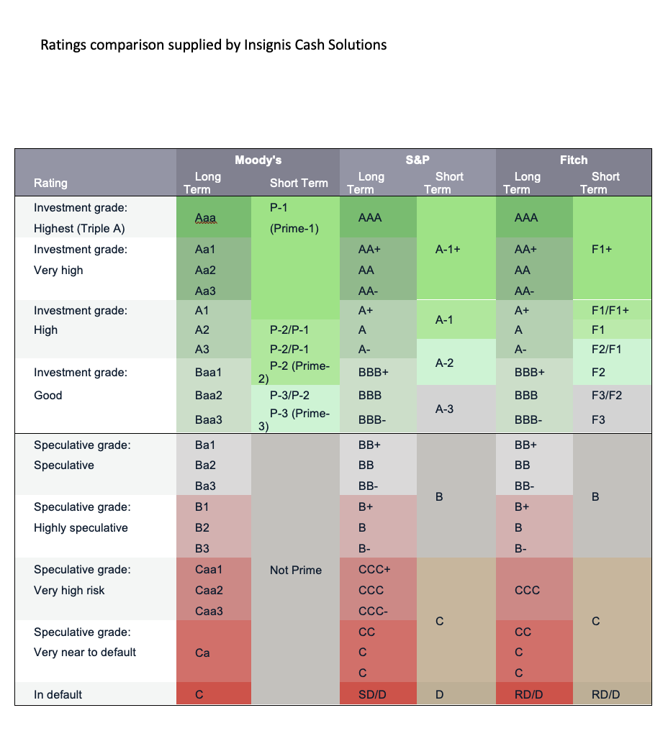
It is recognised that the Trust’s current account balance(s) may exceed the deposit limits stated above. For the purpose of this investment policy, current account balances are excluded from the counterparty limits detailed above.

Assessing liquidity needs
The Trust should ensure that a sufficient balance must be held across accounts with instant access so that the Trust’s financial commitments can be met without the risk of the current account going overdrawn.
It should also allow enough flexibility to deal with reasonable, one-off events should they occur.
The Trust’s cash flow forecasts will dictate how much is available for investment and for how long.
The cashflow forecasts should be reviewed monthly as part of the management accounts cycle and on maturity of fixed term deposits.

Investment Products

The Trust can invest surplus funds in a mixture of interest-bearing accounts and money market facilities (where the capital is not placed at risk) including:
Overnight (instant access)
Notice accounts (typically from 30-days to 100+ days)
Fixed term deposits (typically from 1-month to 12-months)
Investment maturity dates should not exceed 12-months in term.

Investment Decisions

The CFO is responsible for producing reliable cash flow forecasts as a basis for decision making.
The CEO & CFO are responsible for making investment decisions that comply with this Policy.
The opening or closing of bank accounts should be authorised in line with the current ODBST Financial Manual.

Monitoring & Reporting
The CFO will report investments held and the performance of investments against objectives to the FRAPP Committee for review each time it meets or when requested to do so. The reporting should include:
- Funds invested
- Maturity dates
- Interest rates
- Current market rates
- Blended returns achieved against expected performance and policy benchmarks
- Latest cash flows showing 12-month liquidity requirements
- Recommendations for the next 3 months.

Review
Trustees should review the Investment policy to ensure it is still fit for purpose annually.

Authorisation of cash transfers
2 individuals within the finance team will have the capacity to set up a cash transfer.
Authorisation of the transfer will then require a secondary approval from either the CEO, CFO or Deputy CFO.

We aspire for every pupil and adult to ‘experience life in all its fullness’ (John 10:10)

