
Living ‘life in all its fullness’ (John 10:10)
Oxford Diocesan Bucks Schools Trust (ODBST)

“ODBST - Empowering Lives, Flourishing Together”

School Condition Allocation (SCA):

Capital Allocation Policy

ODBST Level 1 Statutory Policy: | ALL Schools require this policy with no changes allowed to core text. No changes are necessary to personalise this with school name and branding, as this is a Trust level policy for use, without change, by all schools, except where a school contact is required as identified in the content of the policy. LGBs will note adoption in LGB meetings. Review will take place at Trust level, and schools will be notified of updates and review dates as necessary.
Other related ODBST policies and procedures: | ODBST Financial Manual  ODBST Estate Strategic Plan  ODBST Sustainability Policy
Committee responsible: | FRAPP
Approved by: | FRAPP
Date Approved: | 10.2.2026
Review Date: | 09/02/2029

Purpose

  - It is the purpose of this document to detail how Oxford Diocesan Bucks Schools Trust (ODBST) will prioritise and allocate School Condition Allocation (SCA) funding on both an annual basis and as part of a rolling programme of improvement across the estate. It sits alongside ODBST’s Estate Strategy (ES) and Sustainability Policy (SP) to ensure transparency in the way in which condition and improvement requirements are prioritised and dealt with.

Scope

  - Trusts are expected to have a suitable plan that demonstrates the strategic use of allocated funds across their estate and will have to report annually to the Department for Education (DfE) on the use of those funds. This document is to be used as a basis for setting out the principles that will be applied by the Trust to ensure best use is being made of SCA funding. SCA is a formula-based allocation of capital funding for eligible Multi-Academy Trusts to maintain and improve the condition of school building, so that children can learn in a safe and effective environment. Investment should be prioritised on keeping Trust buildings safe and in good working order by tackling poor condition, building compliance, energy efficiency and Health and Safety issues. Where required, investment can also be directed towards developing capacity* (sufficiency of pupil places) and curriculum suitability.
* The statutory duty for the provision of school places rests with Local Authorities (LAs) and the administration of Basic Need funding with which to deliver pupil places is administered by LAs. This can place the Trust in a reactive position of responding when approached by LAs to accommodate additional pupils. The need for continual dialogue between LAs and the Trust around emerging place requirement should assist place planning and subsequent capital requirements. There is an expectation that LAs would fund the capital development costs for planned or unmet place need.

Responsibilities

  - The Chief Operations Officer (COO), supported by a procured Surveyor will prepare an annual SCA expenditure proposal and associated three-year rolling improvement programme. Detail around how proposals will be prioritised can be found in the Estate Srategy.

  - The annual proposal/s will be scrutinised by SLT and FRAPP when considering any decisions proposed in line with the ES relating to the allocation of the Trust’s SCA fund.

  - The Finance Risk Audit and Pay Committee (FRAPP) will be requested to approve proposals.

  - Following approval, FRAPP will then monitor effectiveness of spend, SCA reserves balances and satisfaction within the Trust.

Principles

  - Whilst pupil numbers form the determining factor behind the allocation from the DfE, the Trust Board recognises that the age and state of repair of each school will not be directly related to pupil numbers. Any newly built schools within the first 3-5 years of their lifecycles will need far less capital expenditure than other schools within the Trust.
  - This policy document considers the following principles:

    - Condition improvements will be funded through SCA based upon outcomes and analysis of the most recent Condition Survey, Health & Safety Audit, Fire Risk Assessment and Asbestos Management plan, utilising a matrix of assessed risk factors, their severity and the probability of failure.

    - Risk factors will cover Health & Safety and statutory compliance, the impact on the operation of the school, the potential financial and reputational implications and the impact on the ongoing condition of the buildings or elements within them.

    - The application of a consistent methodology will enable different maintenance works to be ranked against each other to ensure issues are addressed in priority order and risks minimised.
    - Any decision must also comply with the principles and conditions as set out in the ODBST Financial Procedures Manual, Academies Trust Handbook and Academies Accounts Direction.

Additional Operational Factors

  - As well as risk-based prioritisation, other factors will be considered to inform the prioritisation of maintenance and improvement works. These factors may impact the operation of a school and could include:

    - The importance of the building, room or area within the building to the operation of the school – for example, how important it is to the learning environment or the business reputation.
    - The prioritisation assessment within the condition survey – how has the condition survey prioritised these works and why?

    - The suitability of the building, room or area for its current purpose – is it fit for purpose and does it meet the needs of users?

    - The longevity of the building, room or area – is it likely to remain in the estate or is there potential for it to be used for another purpose (including internal changes), sold or leased?

    - If carbon neutral alternatives can be considered.

Procedure for SCA Funding Distribution

  - For the Trust to strategically utilise SCA funding for condition and maintenance priorities, the following procedures should be adhered to before the expenditure is committed:
    - All condition grading D & C 1 and 2 rated lines within the schools’ condition survey will be assessed against the Risk Factors Matrix (RFM Appendix 1) and the scoring output used to rank-order priorities. This will be completed by the Trust Facility Manager with advice from the surveyor and reviewed by the COO. Industry advice and assistance could be sought where required to support this process. The RFM is based on an assessment of risk factors, their severity and the probability of failure. The matrix will be used to consider the risk factors and probability of failure of items with a view to ranking projects in order of priority.

    - Ranked D, C raised issues will be confirmed in a priority order and factored into a three-year rolling improvement timeline plan informed by RFM scoring outcomes.

    - Priorities agreed within the rolling three-year plan will be quoted and/or tendered for to ensure annual affordability and compliance with the Trust’s financial policies and procedures. For more complex and/or larger scale projects, external project management may be commissioned from a preferred suppliers list to assist with both project cost estimation and delivery.

    - The annual plans must be flexible enough to respond to new priorities or additions.

  - Proposed improvement priorities for each year will then be recommended by the COO for agreement by the CFO initially and then the FRAPP Committee for approval.

Catering for Emergencies

  - Provision for emergencies needs to be accounted for when distributing funds. By investing funding in capital projects, it is hoped that the occurrence of emergencies will lessen; however, they do occur and funds will need to be made available for such an event.
  - Accordingly, a proportion of SCA funding will be held in reserve for use to rectify sudden failure or deterioration in condition that presents a Health & Safety, safeguarding or significant operational issue. Where the cost to rectify the issue exceeds the ring-fenced amount, any such issue will take precedence over the expenditure plan for the current year. Plans for future years would then need to be revised accordingly.
  - In keeping with SCA allocation timeframes, an allocated annual amount will be ring-fenced to provide funding for uninsured emergency works of a capital nature. The Trust intends to work towards ensuring it has a Capital Contingency Reserve amounting to 15% of the total annual SCA allocation. This is subject to annual review by the COO and CFO as the trust grows and the SCA fund increases.

  - Applications for SCA emergency funding can be made using the form in Appendix 2 of this policy. Completed forms are to be sent to the COO, who will review and respond accordingly.

Approval and Monitoring

  - Any proposal to direct SCA funding to a school must follow the procedure above before it can be committed to.

  - The FRAPP committee will consider the annual proposal presented and where the RFM equally scores priorities, a decision will be carried out based on a majority vote as to which capital projects are included within that year’s allocation.
  - The full Trust Board have the authority to approve both the annual plan and three-year rolling programme.

  - Any decision taken in this regard is considered final.

  - Where there are insufficient funds within SCA to cover critical uninsured Health & Safety and/or condition related projects, top-up from school reserves could be considered; however, this would require sign-off by the Trust Board.

  - Progress towards agreed capital development plans will be routinely reviewed by the FRAPP Committee who will monitor the effectiveness of spend and satisfaction within the Trust.

Appeals and Complaints

  - It is important that any grievances schools may have in relation to the allocation of SCA funding can be expressed.
    - In the event of a school having such a grievance, the Headteacher will be invited to meet with the COO, Trust surveyor and CFO to discuss their allocation and any areas of concern. Appendix 2 can be used as a template for structuring an appeal.

    - The original decision will be reviewed and either confirmed or amended.

    - Where a school is still not satisfied with the outcome, a request can be made to the FRAPP Committee of the Trust Board for a further review of the process followed and subsequent outcome. The decision of the FRAPP Committee will be final.

Appendix 1

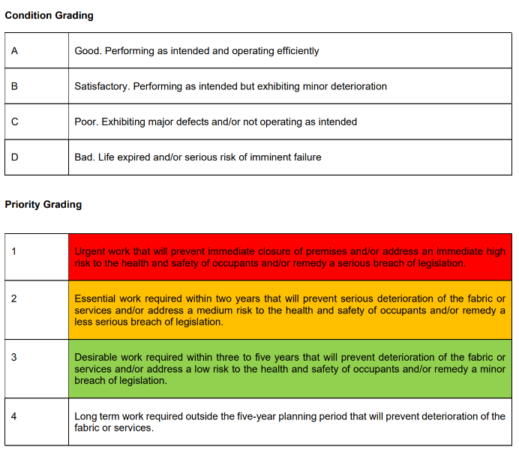

Severity of Consequences
Insignificant
Minor
Moderate
Major
Catastrophic

Probability of Failure
1 | Unlikely | Operationally sound. Normal wear and tear. Estimated time to failure 5-10 years.
2 | Possible | Some signs of minor deterioration/ damage. Estimated time to failure up to 5 years
3 | Likely | Signs of significant deterioration/damage. Estimated time to failure within a year.
4 | Certain | Failure imminent or has already occurred.

 |  |  |  |  |  |  | Probability of failure
 |  |  |  |  |  |  | 1 | 2 | 3 | 4
 | Severity |  | Health and safety/statutory compliance | Operational/service interruption | Maintenance budget/business/financi al | Building condition/  deterioration | Unlikely | Possib-le | Likely | Certain
 | 1 | Insignificant | No risk of injury or breach of procedures | Minimal or no impact on school operation | Minimal or no impact on reactive maintenance budget or reputation | Work can be delayed without affecting condition of building or  services | 1 | 2 | 3 | 4
 | 2 | Minor | Minor injury, trivial breach of procedures or minimal breach of legal  requirements | Localised impact, little disruption or impact on school operation | Possible impact on reactive maintenance budget, complaint or  impact on reputation | Could develop into minor deterioration of building or services if  delayed | 2 | 4 | 6 | 8
Severity of consequences | 3 | Moderate | Injury or illness resulting in absence, significant breach of procedures or  legal requirements | Impact on large part of school, disruption to normal school operation | Significant impact on reactive maintenance budget, reputational  impact, financial penalty | Will result in significant deterioration of building fabric or services if  delayed | 3 | 6 | 9 | 12
 |  |  | Major injury, notifiable |  | Major impact on reactive maintenance budget, loss of reputation, financial penalty | Serious deterioration of
 |  |  | breach of legal | Major impact and |  | building and services
 | 4 | Major | requirements or | disruption to whole |  | and drop in overall | 4 | 8 | 12 | 16
 |  |  | procedures, litigation | school operation |  | condition category if
 |  |  | likely |  |  | delayed
 | 5 | Catastrophic | Fatality, prosecution from legal breach | Failure results in closure of whole school operation | Extensive impact on maintenance or capital budgets, reputational impact, significant financial  penalties | Will result in complete building failure, unsuitable for occupation if delayed | 5 | 10 | 15 | 20

Appendix 2 Emergency SCA or School SCA request form

School Name
Emergency SCA /SCHOOL SCA budget request title (delete)
Description of Works (Brief description)
Business Case (Justification for works etc)
Assessment of impact on pupil outcomes if approved
Estimated Cost (Please include at least one valid quote) | .
School Contribution
Suggested Start Date
Senior Administrator
(Signature)
Head Teacher (Signature)
To be completed by the Operations Department:

Does this meet the emergency/spend criteria? | YES / NO
Have the required number of quotes been obtained? | YES / NO
If the answer to either of the above is NO, then please provide further information.
Outcome | APPROVED / REJECTED | Date
Signed |  | Role

